Curriculum  Vitae | 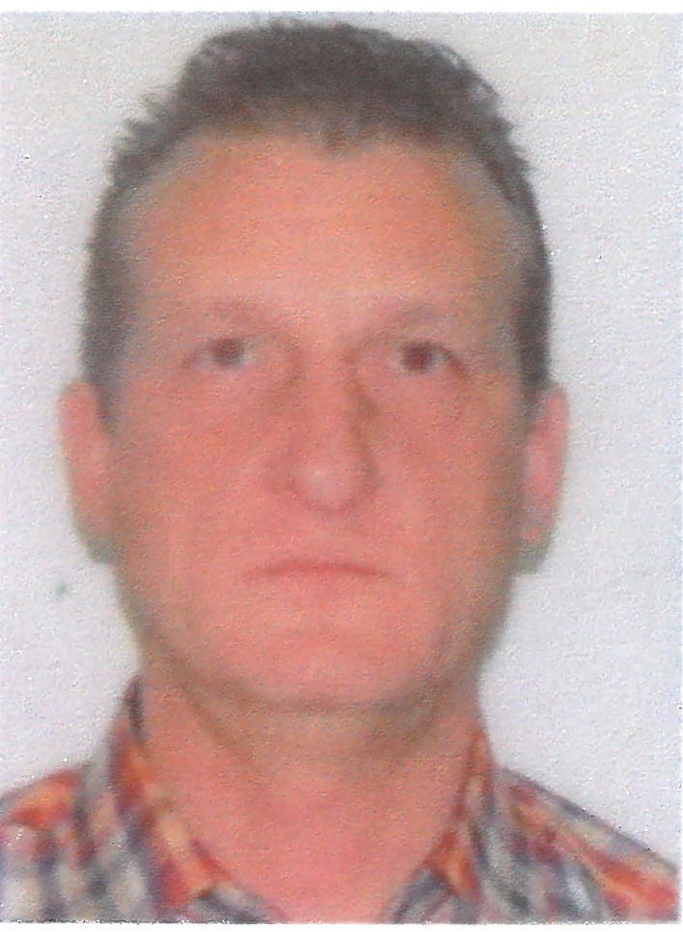
Personal information
First / Last Name | OPRIŞAN GABRIEL PETRISOR
Address | Str. Grădina Veche nr. 95, Localitatea Galaţi , cod poştal 800142, România
Phone Number | +40. 753. 831. 029
E-mail | gopgabi@yahoo.com
Nationality | Română
Data of birth | 12th of octomber 1967
Sex | Masculin
Work place | - 2017 – 2019 (May) - Project Manager – Private Company – activity location : Damen - Shipyard Galati - Romania; VARD FICANTIERI - Shipyard Tulcea - Romania; Vard Pipeing, STX France = Chantiers de L”Atlantique – Saint Nazaire – France.
Professional Experience  Period  Position / Company | 1986 – 1986 – electronics – Radio Communications Department at CFR Galati;  1986 – 1988 – Military Service – MAI;  1988 – 1993 – Program Analist at Regionala CFR Galaţi;  1993 – 1996 – Treasury Head of Department at Credit Bank Galaţi;  1996 – 1997 - Treasury Head of Department at EuroBank Galaţi;  1997 – 2006 – General Director - S.C.PAGANELLI SRL - Domain : Civil & industrial constructions; Furniture production; Repairs & design boats and houses;  2006 – 2009 – General Director - S.C. PALEXPERT SRL – Domain: Civil & industrial constructions; Furniture production; Repairs & design boats and houses;  2009 – 2012 – Sales Manager & Technical Manager - S.C. EUROTEHNICA S.A. – Greek-romanin company – developer of civil & industrial constructions (apartments & parking areas);  2012 – 2017 – Technical Supervisior - QC - ArcelorMittal Refractories Polond – relocated in Romania for ArcelorMittal Galati, ArcelorMittal Hunedoara, Oteluri Speciale Targoviste, ArcelorMittal Tubular Product Galati, Roman – supervision of the ongoing projects in Romania, also for work security and nature protection;  - Technical Manager – promotion of the ArcelorMittal Refractories products in Romania;  2017 – 2019 / present – Project Manager – Private Company – activity : New Shipbuilding  - activity locations: Damen - Shipyard Galati - Romania; VARD FICANTIERI - Shipyard Tulcea - Romania; STX France; Chantiers de L”Atlantique – Saint Nazaire – France; - supervision of the ongoing projects; coordonation of the workmen (engineers, masters, workers); implementation of the new projects in the production process. BEST COLABORATIONS WITH TEAM QC, QA, DNV GL. Identification, analyzing, and informing the workmen of the risks and control of the workplace; estimation of the needed resources for the projects; identification of the resourses and preparing programs for the projects, as well as making assurance of the optional resourses for finishing the projects.
Education
Period | * 1975 – 1982 – Middle School no. 23 Galati;  * 1982 – 1986 – CFR Highschool – electrotechnic major;  * 1986 – 1988 – Military Service – MAI;  * 1988 – 1989 – Informatic systems programmer & analist courses;  * 1988 – 1991 – ASE – Economic Studies Academy – finance;  * 1991 – 1992 – Computer studies – Microsoft;  * 2006 – 2007 – Quality Management courses ISO 14001 / 9001;  * 2007 – 2008 – Design courses: interior/exterior design; civil & industrial & naval constructions;  * „Dunarea de Jos” University Galati - Faculty of Engineering – Bachelor’s degree in : applied infromatics in materials’ engineering;  * „Dunarea de Jos” University Galati - Faculty of Engineering – Master’s degree in materials’ engineering – Advanced materials and innovative naval technologies.
Personal qualifications
Mother language | Romanian
Foreign language | English, Franch, Greek
Autoevaluation |  | Understanding |  |  |  |  | Speaking |  |  |  |  | Writing
European level (*) |  | Listening |  | Reading |  |  | Conversation |  | Monolog |  |  | Writing
English |  |  | Medium |  | Medium |  |  | Medium |  |  | Medium |  | Medium
Franch |  |  | Medium |  | Medium |  |  | Medium |  |  | Medium |  | Medium
Greek |  |  | Beginner |  | Beginner |  |  | Beginner |  |  | Beginner |  | Beginner
Social abilities | -Concentrating on my work and prioritizing it in such way so that it flourishes;  -Taking responsability for reach the highest working performances;  - Freely comunincating in a correct and respectful manner;  - Making efforts for having a positive impact on others;  - Efficient collaboration and stimulating the work team to reach our goal;  - Easily adjucting to a changing environment; supportinng a proactive change  - Making a proper evaluation of all factors before taking a decision;  - Having the capacity of taking propper decision in a state of emergency;  - Accepting effectiv immediately a certain way of working and looking for way to making it better.
Organizing Abilities | - Experience in ordering and selecting products;  - Storing of the materials, documents, and of all the information;  - Making the inventory and lists of needed products;  - Making daily/weekly/monthly reports of the ongoing projects;  - Finding efficient ways for reducing the production costs;  - Monitoring the performance incides;  - Taking care of the product invetory;  - Efficient time management for the company’s best interests.
Technical Abilities | - Thorough knowledge regarding the materials used in the metallurgical industry;  - Car production;  - Naval construction;  - Civil & industrial constructions;  - Electrical installations, AC, ventilation;  - Furniture industry, home & design
IT Abilities | - Ability of using any type of Windows operating system;  - Ability of using MS Office Excel, Word, Adobe, PowerPoint, ACDSEE, Paint, AutoGrafics, Autocad, etc;  - Different operating systems in the domains that I worked in;  - Internet navigation, research;
Other Licenses | - Driving License - B category since 1992 (without incidents);  - Boat driving License since 2002 (without incidents);  - Other Licenses
Other information | - Reference and intention letters can be sent on demand  - Available for relocation (in Romania or in other countries), available for business trips;  - Hobbies : learining about new business fields and about promotion of products & marketing; civil design; sports such as tennis, volley-ball, football, swimming; navigation; boats; fishing; tourism; cooking; etc.

